3)Cold Migration of VM from one host to another

Aim:
To perform cold migration of a virtual machine (VM) from one host to another using the export/import appliance method (OVA format) in order to transfer VM configurations and disk data seamlessly while the VM is powered off.
STEPS:
Prerequisite
- VM must be shut down (powered off).
- Both systems (source and destination) must have VirtualBox
- Ensure enough storage on destination host.
1)Created a java file to check whether the same file exist in vm after imported(cold migrated ) in another system
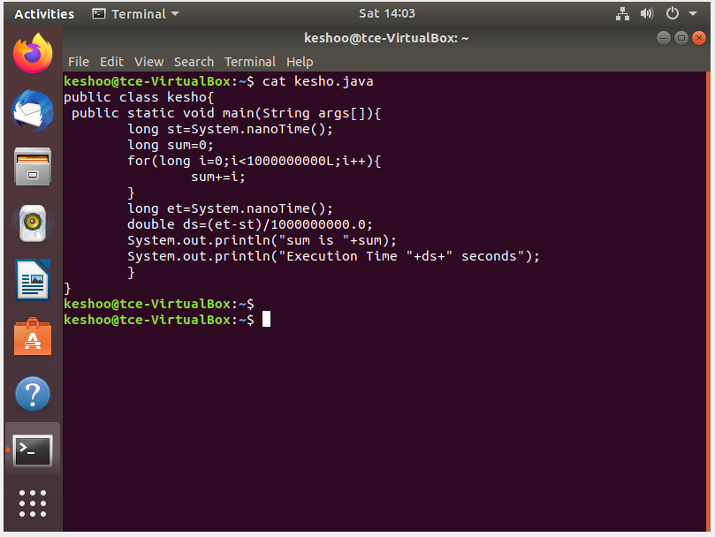
2)Shut down the VM completely. Open VirtualBox and select the VM → Click File > Export Appliance (or File > Export OVF).
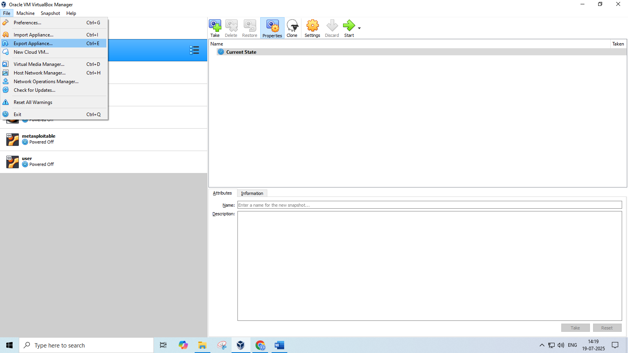

3) Select the vm which you want to export
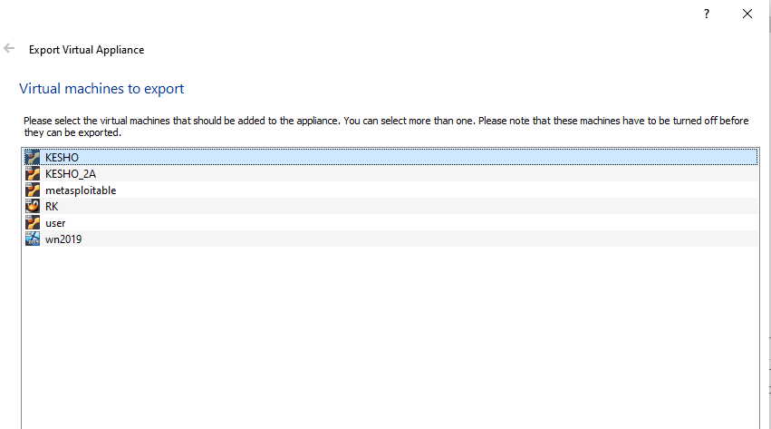

4)Select the format which you want to export ova or ovf file format and select the path where you want to export in the file system
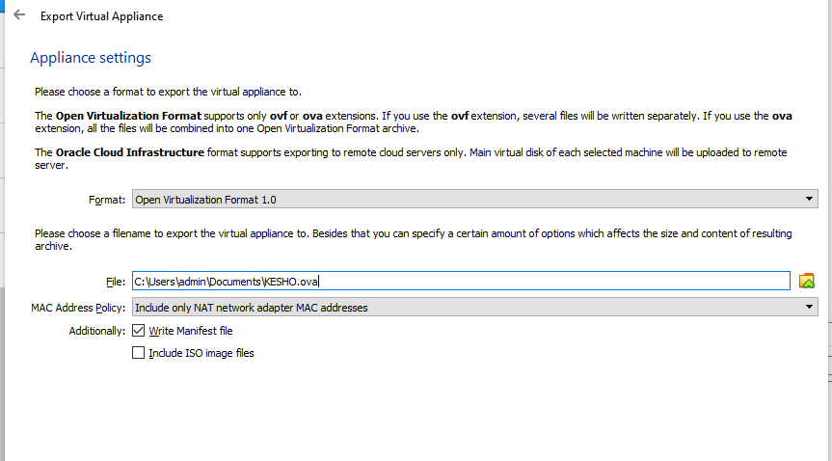
5)Click export to (export appliance to the file system where you selected the location)
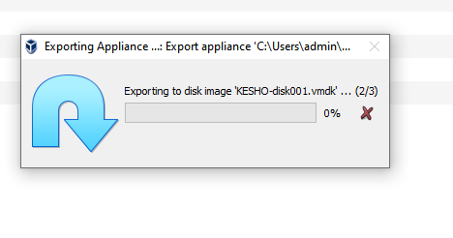
6) Check the folder whether the ova image has been present in the folder
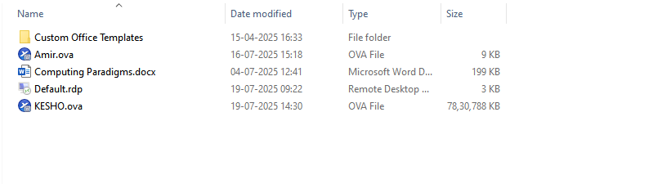
7) Copy the image to the external device via internet , USB etc I am using the usb and stored in my smartphone y3005G.

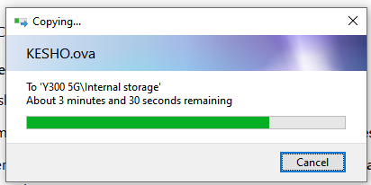
8)Copy the image from your external device to the destination machine via usb
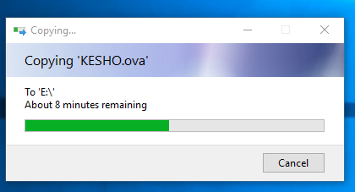
8) On the Destination Host: Import the OVA Open VirtualBox Go to File > Import Appliance (or File > Open). Browse and select the .ova file you transferred.
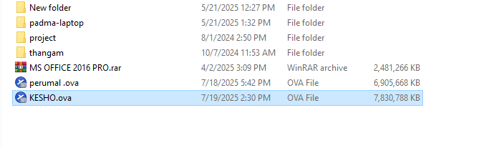

9) Import the image by import appliance in the file ->import appliance
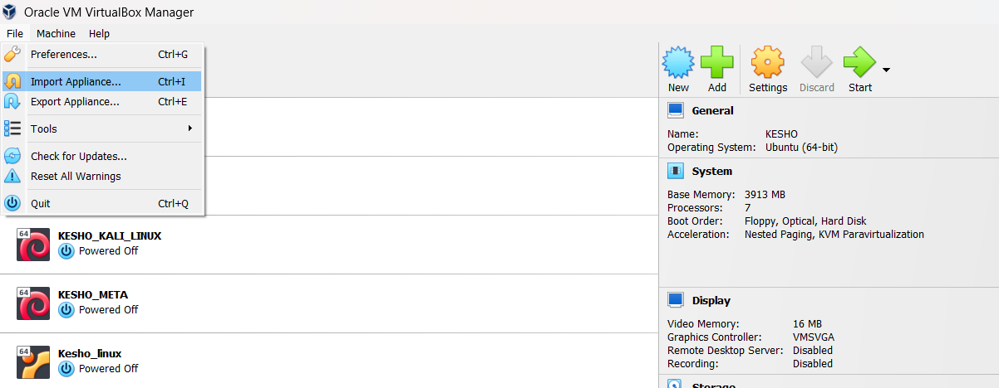
10)Now the image has been importing
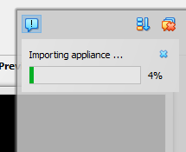
11)Check whether the vm is shown in the oracle virtual box and open it

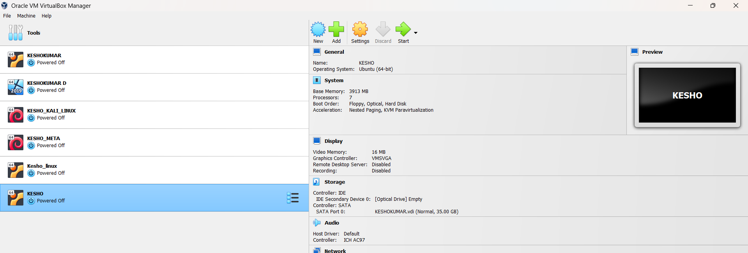
12)Open the java file which you saved first using the linux commands cat kesho.java
And its verified that the file are located and cold migration has done
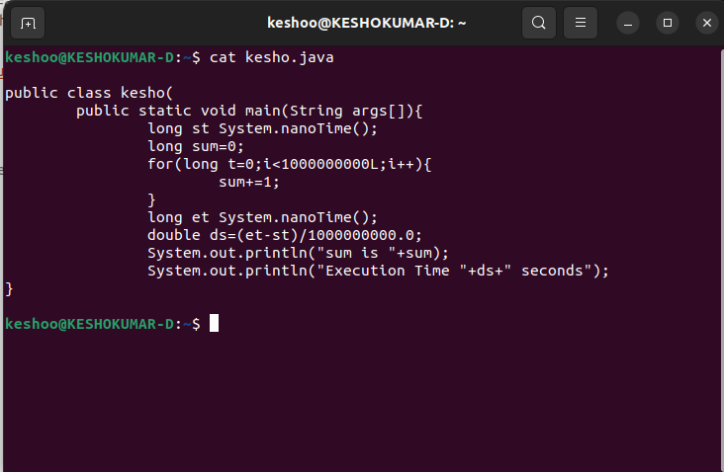

RESULT:
The virtual machine was successfully migrated to the destination host in a powered-off state(cold migration) using the OVA export/import method. All configurations and data were retained, and the VM booted up and functioned correctly on the new host.

